# Ariel Romero

## Clustering Assignment

options(tidyverse.quiet=TRUE)  
library(tidyverse)  
library(cluster)  
library(factoextra)

## Welcome! Related Books: `Practical Guide To Cluster Analysis in R` at https://goo.gl/13EFCZ

library(dendextend)

##   
## ---------------------  
## Welcome to dendextend version 1.12.0  
## Type citation('dendextend') for how to cite the package.  
##   
## Type browseVignettes(package = 'dendextend') for the package vignette.  
## The github page is: https://github.com/talgalili/dendextend/  
##   
## Suggestions and bug-reports can be submitted at: https://github.com/talgalili/dendextend/issues  
## Or contact: <tal.galili@gmail.com>  
##   
## To suppress this message use: suppressPackageStartupMessages(library(dendextend))  
## ---------------------

##   
## Attaching package: 'dendextend'

## The following object is masked from 'package:stats':  
##   
## cutree

trucks <- read_csv("trucks.csv")

## Parsed with column specification:  
## cols(  
## Driver_ID = col_double(),  
## Distance = col_double(),  
## Speeding = col_double()  
## )

str(trucks)

## Classes 'spec_tbl_df', 'tbl_df', 'tbl' and 'data.frame': 4000 obs. of 3 variables:  
## $ Driver_ID: num 3.42e+09 3.42e+09 3.42e+09 3.42e+09 3.42e+09 ...  
## $ Distance : num 71.2 52.5 64.5 55.7 54.6 ...  
## $ Speeding : num 28 25 27 22 25 10 20 8 34 19 ...  
## - attr(*, "spec")=  
## .. cols(  
## .. Driver_ID = col_double(),  
## .. Distance = col_double(),  
## .. Speeding = col_double()  
## .. )

summary(trucks)

## Driver_ID Distance Speeding   
## Min. :3.423e+09 Min. : 15.52 Min. : 0.00   
## 1st Qu.:3.423e+09 1st Qu.: 45.25 1st Qu.: 4.00   
## Median :3.423e+09 Median : 53.33 Median : 6.00   
## Mean :3.423e+09 Mean : 76.04 Mean : 10.72   
## 3rd Qu.:3.423e+09 3rd Qu.: 65.63 3rd Qu.: 9.00   
## Max. :3.423e+09 Max. :244.79 Max. :100.00

ggplot(trucks, aes(x=Distance, y= Speeding)) +geom_point()

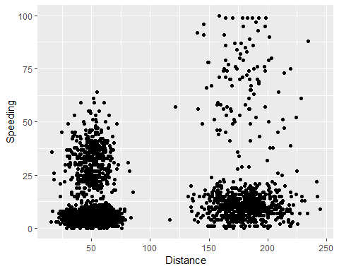

The relationship between Disance and Speeding seems to be non-linear with 4 potential clusters in the data.

trucks2 = select(trucks, Distance, Speeding)  
trucks2_scaled = as.data.frame(scale(trucks2))  
summary(trucks2)

## Distance Speeding   
## Min. : 15.52 Min. : 0.00   
## 1st Qu.: 45.25 1st Qu.: 4.00   
## Median : 53.33 Median : 6.00   
## Mean : 76.04 Mean : 10.72   
## 3rd Qu.: 65.63 3rd Qu.: 9.00   
## Max. :244.79 Max. :100.00

set.seed(1234)  
  
clusters1 <- kmeans(trucks2,2)  
  
fviz_cluster(clusters1, trucks2_scaled)

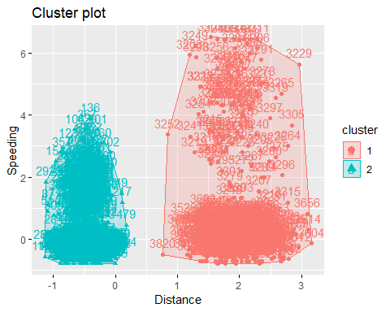

It appears that the observations in the data sets do not share common characteristics.

set.seed(123)  
  
fviz_nbclust(trucks2_scaled, kmeans, method = "wss")

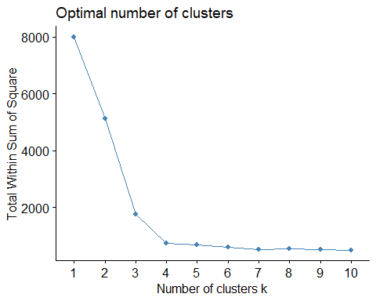

set.seed(123)  
fviz_nbclust(trucks2_scaled,kmeans, method = "silhouette")

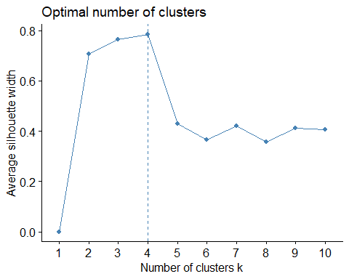

set.seed(1234)  
  
clusters1 <- kmeans(trucks2_scaled,4)  
clusters1

## K-means clustering with 4 clusters of sizes 695, 2774, 104, 427  
##   
## Cluster means:  
## Distance Speeding  
## 1 1.9523882 -0.01396965  
## 2 -0.4867234 -0.40244705  
## 3 1.9037667 4.34528041  
## 4 -0.4794634 1.57889429  
##   
## Clustering vector:  
## [1] 4 4 4 4 4 2 4 2 4 4 4 4 4 4 4 4 4 4 4 4 4 4 2 4 4 4 4 2 4 4 4 4 4 4  
## [35] 4 4 4 4 4 4 4 2 4 4 4 2 4 4 4 4 4 4 4 4 4 4 4 4 2 4 4 4 4 4 4 4 4 4  
## [69] 4 4 4 2 4 4 4 4 4 4 4 4 4 2 4 2 4 2 4 4 4 4 4 2 4 4 4 4 4 4 4 4 4 4  
## [103] 2 4 4 4 4 4 4 4 4 2 4 4 4 4 4 4 4 4 4 4 4 4 4 4 4 4 4 4 4 4 4 2 4 4  
## [137] 4 4 2 4 4 4 4 4 2 4 2 4 4 4 4 4 4 4 4 4 4 2 4 4 4 4 4 4 2 4 4 4 4 4  
## [171] 4 4 4 4 4 4 4 4 4 4 2 4 4 4 4 4 4 4 2 4 2 4 4 4 4 4 4 4 4 4 4 4 4 4  
## [205] 4 4 4 4 4 4 2 4 4 4 4 4 4 4 4 4 4 4 4 4 4 4 4 4 4 4 4 4 4 4 4 4 4 4  
## [239] 4 4 4 4 4 4 4 4 4 4 4 2 4 4 4 2 4 4 4 4 4 4 4 4 4 2 4 4 4 4 4 4 4 4  
## [273] 4 4 4 4 2 4 4 4 4 4 4 2 4 4 2 4 4 4 4 4 4 4 4 2 4 4 4 4 4 4 4 4 4 4  
## [307] 4 4 4 4 4 4 4 4 4 4 4 2 4 4 4 4 4 4 4 2 4 4 4 4 4 4 4 4 4 4 4 2 4 4  
## [341] 4 4 4 4 4 2 4 2 4 4 4 4 4 4 4 4 4 4 4 2 4 4 4 4 4 4 4 4 4 4 4 4 4 4  
## [375] 4 4 4 4 4 4 4 4 4 4 4 4 4 2 4 4 4 2 4 4 4 4 4 4 4 4 4 4 4 4 4 4 4 4  
## [409] 2 2 4 4 4 4 2 2 2 4 4 2 4 4 4 4 4 4 4 4 4 4 4 4 4 4 4 4 4 2 4 2 2 2  
## [443] 2 4 4 4 4 4 4 4 4 4 2 4 2 4 4 4 4 4 4 4 4 4 4 4 4 4 4 4 4 4 4 4 4 4  
## [477] 4 4 2 4 2 2 2 2 2 2 2 2 2 2 2 2 2 2 2 2 2 2 2 2 2 2 2 2 2 2 2 2 2 2  
## [511] 2 2 2 2 2 2 2 2 2 2 2 2 2 2 2 2 2 2 2 2 2 2 2 2 2 2 2 2 2 2 2 2 2 2  
## [545] 2 2 2 2 2 2 2 2 2 2 2 2 2 2 2 2 2 2 2 2 2 2 2 2 2 2 2 2 2 2 2 2 2 2  
## [579] 2 2 2 2 2 2 2 2 2 2 2 2 2 2 2 2 2 2 2 2 2 2 2 2 2 2 2 2 2 2 2 2 2 2  
## [613] 2 2 2 2 2 2 2 2 2 2 2 2 2 2 2 2 2 2 2 2 2 2 2 2 2 2 2 2 2 2 2 2 2 2  
## [647] 2 2 2 2 2 2 2 2 2 2 2 2 2 2 2 2 2 2 2 2 2 2 2 2 2 2 2 2 2 2 2 2 2 2  
## [681] 2 2 2 2 2 2 2 2 2 2 2 2 2 2 2 2 2 2 2 2 2 2 2 2 2 2 2 2 2 2 2 2 2 2  
## [715] 2 2 2 2 2 2 2 2 2 2 2 2 2 2 2 2 2 2 2 2 2 2 2 2 2 2 2 2 2 2 2 2 2 2  
## [749] 2 2 2 2 2 2 2 2 2 2 2 2 2 2 2 2 2 2 2 2 2 2 2 2 2 2 2 2 2 2 2 2 2 2  
## [783] 2 2 2 2 2 2 2 2 2 2 2 2 2 2 2 2 2 2 2 2 2 2 2 2 2 2 2 2 2 2 2 2 2 2  
## [817] 2 2 2 2 2 2 2 2 2 2 2 2 2 2 2 2 2 2 2 2 2 2 2 2 2 2 2 2 2 2 2 2 2 2  
## [851] 2 2 2 2 2 2 2 2 2 2 2 2 2 2 2 2 2 2 2 2 2 2 2 2 2 2 2 2 2 2 2 2 2 2  
## [885] 2 2 2 2 2 2 2 2 2 2 2 2 2 2 2 2 2 2 2 2 2 2 2 2 2 2 2 2 2 2 2 2 2 2  
## [919] 2 2 2 2 2 2 2 2 2 2 2 2 2 2 2 2 2 2 2 2 2 2 2 2 2 2 2 2 2 2 2 2 2 2  
## [953] 2 2 2 2 2 2 2 2 2 2 2 2 2 2 2 2 2 2 2 2 2 2 2 2 2 2 2 2 2 2 2 2 2 2  
## [987] 2 2 2 2 2 2 2 2 2 2 2 2 2 2 2 2 2 2 2 2 2 2 2 2 2 2 2 2 2 2 2 2 2 2  
## [1021] 2 2 2 2 2 2 2 2 2 2 2 2 2 2 2 2 2 2 2 2 2 2 2 2 2 2 2 2 2 2 2 2 2 2  
## [1055] 2 2 2 2 2 2 2 2 2 2 2 2 2 2 2 2 2 2 2 2 2 2 2 2 2 2 2 2 2 2 2 2 2 2  
## [1089] 2 2 2 2 2 2 2 2 2 2 2 2 2 2 2 2 2 2 2 2 2 2 2 2 2 2 2 2 2 2 2 2 2 2  
## [1123] 2 2 2 2 2 2 2 2 2 2 2 2 2 2 2 2 2 2 2 2 2 2 2 2 2 2 2 2 2 2 2 2 2 2  
## [1157] 2 2 2 2 2 2 2 2 2 2 2 2 2 2 2 2 2 2 2 2 2 2 2 2 2 2 2 2 2 2 2 2 2 2  
## [1191] 2 2 2 2 2 2 2 2 2 2 2 2 2 2 2 2 2 2 2 2 2 2 2 2 2 2 2 2 2 2 2 2 2 2  
## [1225] 2 2 2 2 2 2 2 2 2 2 2 2 2 2 2 2 2 2 2 2 2 2 2 2 2 2 2 2 2 2 2 2 2 2  
## [1259] 2 2 2 2 2 2 2 2 2 2 2 2 2 2 2 2 2 2 2 2 2 2 2 2 2 2 2 2 2 2 2 2 2 2  
## [1293] 2 2 2 2 2 2 2 2 2 2 2 2 2 2 2 2 2 2 2 2 2 2 2 2 2 2 2 2 2 2 2 2 2 2  
## [1327] 2 2 2 2 2 2 2 2 2 2 2 2 2 2 2 2 2 2 2 2 2 2 2 2 2 2 2 2 2 2 2 2 2 2  
## [1361] 2 2 2 2 2 2 2 2 2 2 2 2 2 2 2 2 2 2 2 2 2 2 2 2 2 2 2 2 2 2 2 2 2 2  
## [1395] 2 2 2 2 2 2 2 2 2 2 2 2 2 2 2 2 2 2 2 2 2 2 2 2 2 2 2 2 2 2 2 2 2 2  
## [1429] 2 2 2 2 2 2 2 2 2 2 2 2 2 2 2 2 2 2 2 2 2 2 2 2 2 2 2 2 2 2 2 2 2 2  
## [1463] 2 2 2 2 2 2 2 2 2 2 2 2 2 2 2 2 2 2 2 2 2 2 2 2 2 2 2 2 2 2 2 2 2 2  
## [1497] 2 2 2 2 2 2 2 2 2 2 2 2 2 2 2 2 2 2 2 2 2 2 2 2 2 2 2 2 2 2 2 2 2 2  
## [1531] 2 2 2 2 2 2 2 2 2 2 2 2 2 2 2 2 2 2 2 2 2 2 2 2 2 2 2 2 2 2 2 2 2 2  
## [1565] 2 2 2 2 2 2 2 2 2 2 2 2 2 2 2 2 2 2 2 2 2 2 2 2 2 2 2 2 2 2 2 2 2 2  
## [1599] 2 2 2 2 2 2 2 2 2 2 2 2 2 2 2 2 2 2 2 2 2 2 2 2 2 2 2 2 2 2 2 2 2 2  
## [1633] 2 2 2 2 2 2 2 2 2 2 2 2 2 2 2 2 2 2 2 2 2 2 2 2 2 2 2 2 2 2 2 2 2 2  
## [1667] 2 2 2 2 2 2 2 2 2 2 2 2 2 2 2 2 2 2 2 2 2 2 2 2 2 2 2 2 2 2 2 2 2 2  
## [1701] 2 2 2 2 2 2 2 2 2 2 2 2 2 2 2 2 2 2 2 2 2 2 2 2 2 2 2 2 2 2 2 2 2 2  
## [1735] 2 2 2 2 2 2 2 2 2 2 2 2 2 2 2 2 2 2 2 2 2 2 2 2 2 2 2 2 2 2 2 2 2 2  
## [1769] 2 2 2 2 2 2 2 2 2 2 2 2 2 2 2 2 2 2 2 2 2 2 2 2 2 2 2 2 2 2 2 2 2 2  
## [1803] 2 2 2 2 2 2 2 2 2 2 2 2 2 2 2 2 2 2 2 2 2 2 2 2 2 2 2 2 2 2 2 2 2 2  
## [1837] 2 2 2 2 2 2 2 2 2 2 2 2 2 2 2 2 2 2 2 2 2 2 2 2 2 2 2 2 2 2 2 2 2 2  
## [1871] 2 2 2 2 2 2 2 2 2 2 2 2 2 2 2 2 2 2 2 2 2 2 2 2 2 2 2 2 2 2 2 2 2 2  
## [1905] 2 2 2 2 2 2 2 2 2 2 2 2 2 2 2 2 2 2 2 2 2 2 2 2 2 2 2 2 2 2 2 2 2 2  
## [1939] 2 2 2 2 2 2 2 2 2 2 2 2 2 2 2 2 2 2 2 2 2 2 2 2 2 2 2 2 2 2 2 2 2 2  
## [1973] 2 2 2 2 2 2 2 2 2 2 2 2 2 2 2 2 2 2 2 2 2 2 2 2 2 2 2 2 2 2 2 2 2 2  
## [2007] 2 2 2 2 2 2 2 2 2 2 2 2 2 2 2 2 2 2 2 2 2 2 2 2 2 2 2 2 2 2 2 2 2 2  
## [2041] 2 2 2 2 2 2 2 2 2 2 2 2 2 2 2 2 2 2 2 2 2 2 2 2 2 2 2 2 2 2 2 2 2 2  
## [2075] 2 2 2 2 2 2 2 2 2 2 2 2 2 2 2 2 2 2 2 2 2 2 2 2 2 2 2 2 2 2 2 2 2 2  
## [2109] 2 2 2 2 2 2 2 2 2 2 2 2 2 2 2 2 2 2 2 2 2 2 2 2 2 2 2 2 2 2 2 2 2 2  
## [2143] 2 2 2 2 2 2 2 2 2 2 2 2 2 2 2 2 2 2 2 2 2 2 2 2 2 2 2 2 2 2 2 2 2 2  
## [2177] 2 2 2 2 2 2 2 2 2 2 2 2 2 2 2 2 2 2 2 2 2 2 2 2 2 2 2 2 2 2 2 2 2 2  
## [2211] 2 2 2 2 2 2 2 2 2 2 2 2 2 2 2 2 2 2 2 2 2 2 2 2 2 2 2 2 2 2 2 2 2 2  
## [2245] 2 2 2 2 2 2 2 2 2 2 2 2 2 2 2 2 2 2 2 2 2 2 2 2 2 2 2 2 2 2 2 2 2 2  
## [2279] 2 2 2 2 2 2 2 2 2 2 2 2 2 2 2 2 2 2 2 2 2 2 2 2 2 2 2 2 2 2 2 2 2 2  
## [2313] 2 2 2 2 2 2 2 2 2 2 2 2 2 2 2 2 2 2 2 2 2 2 2 2 2 2 2 2 2 2 2 2 2 2  
## [2347] 2 2 2 2 2 2 2 2 2 2 2 2 2 2 2 2 2 2 2 2 2 2 2 2 2 2 2 2 2 2 2 2 2 2  
## [2381] 2 2 2 2 2 2 2 2 2 2 2 2 2 2 2 2 2 2 2 2 2 2 2 2 2 2 2 2 2 2 2 2 2 2  
## [2415] 2 2 2 2 2 2 2 2 2 2 2 2 2 2 2 2 2 2 2 2 2 2 2 2 2 2 2 2 2 2 2 2 2 2  
## [2449] 2 2 2 2 2 2 2 2 2 2 2 2 2 2 2 2 2 2 2 2 2 2 2 2 2 2 2 2 2 2 2 2 2 2  
## [2483] 2 2 2 2 2 2 2 2 2 2 2 2 2 2 2 2 2 2 2 2 2 2 2 2 2 2 2 2 2 2 2 2 2 2  
## [2517] 2 2 2 2 2 2 2 2 2 2 2 2 2 2 2 2 2 2 2 2 2 2 2 2 2 2 2 2 2 2 2 2 2 2  
## [2551] 2 2 2 2 2 2 2 2 2 2 2 2 2 2 2 2 2 2 2 2 2 2 2 2 2 2 2 2 2 2 2 2 2 2  
## [2585] 2 2 2 2 2 2 2 2 2 2 2 2 2 2 2 2 2 2 2 2 2 2 2 2 2 2 2 2 2 2 2 2 2 2  
## [2619] 2 2 2 2 2 2 2 2 2 2 2 2 2 2 2 2 2 2 2 2 2 2 2 2 2 2 2 2 2 2 2 2 2 2  
## [2653] 2 2 2 2 2 2 2 2 2 2 2 2 2 2 2 2 2 2 2 2 2 2 2 2 2 2 2 2 2 2 2 2 2 2  
## [2687] 2 2 2 2 2 2 2 2 2 2 2 2 2 2 2 2 2 2 2 2 2 2 2 2 2 2 2 2 2 2 2 2 2 2  
## [2721] 2 2 2 2 2 2 2 2 2 2 2 2 2 2 2 2 2 2 2 2 2 2 2 2 2 2 2 2 2 2 2 2 2 2  
## [2755] 2 2 2 2 2 2 2 2 2 2 2 2 2 2 2 2 2 2 2 2 2 2 2 2 2 2 2 2 2 2 2 2 2 2  
## [2789] 2 2 2 2 2 2 2 2 2 2 2 2 2 2 2 2 2 2 2 2 2 2 2 2 2 2 2 2 2 2 2 2 2 2  
## [2823] 2 2 2 2 2 2 2 2 2 2 2 2 2 2 2 2 2 2 2 2 2 2 2 2 2 2 2 2 2 2 2 2 2 2  
## [2857] 2 2 2 2 2 2 2 2 2 2 2 2 2 2 2 2 2 2 2 2 2 2 2 2 2 2 2 2 2 2 2 2 2 2  
## [2891] 2 2 2 2 2 2 2 2 2 2 2 2 2 2 2 2 2 2 2 2 2 2 2 2 2 2 2 2 2 2 2 2 2 2  
## [2925] 2 2 2 2 2 2 2 2 2 2 2 2 2 2 2 2 2 2 2 2 2 2 2 2 2 2 2 2 2 2 2 2 2 2  
## [2959] 2 2 2 2 2 2 2 2 2 2 2 2 2 2 2 2 2 2 2 2 2 2 2 2 2 2 2 2 2 2 2 2 2 2  
## [2993] 2 2 2 2 2 2 2 2 2 2 2 2 2 2 2 2 2 2 2 2 2 2 2 2 2 2 2 2 2 2 2 2 2 2  
## [3027] 2 2 2 2 2 2 2 2 2 2 2 2 2 2 2 2 2 2 2 2 2 2 2 2 2 2 2 2 2 2 2 2 2 2  
## [3061] 2 2 2 2 2 2 2 2 2 2 2 2 2 2 2 2 2 2 2 2 2 2 2 2 2 2 2 2 2 2 2 2 2 2  
## [3095] 2 2 2 2 2 2 2 2 2 2 2 2 2 2 2 2 2 2 2 2 2 2 2 2 2 2 2 2 2 2 2 2 2 2  
## [3129] 2 2 2 2 2 2 2 2 2 2 2 2 2 2 2 2 2 2 2 2 2 2 2 2 2 2 2 2 2 2 2 2 2 2  
## [3163] 2 2 2 2 2 2 2 2 2 2 2 2 2 2 2 2 2 2 2 2 2 2 2 2 2 2 2 2 2 2 2 2 2 2  
## [3197] 2 2 2 2 3 3 3 3 3 3 1 3 3 3 3 3 3 1 3 1 3 3 3 3 1 3 3 3 3 3 3 3 3 3  
## [3231] 3 3 3 3 3 3 3 3 3 3 3 1 3 3 3 3 3 1 3 1 3 3 3 3 3 3 3 3 3 3 3 1 3 3  
## [3265] 3 3 3 3 3 3 3 3 3 3 3 3 3 3 1 3 1 3 3 3 3 3 3 3 1 3 3 3 1 3 3 1 3 3  
## [3299] 3 3 1 3 3 3 3 3 3 3 3 3 3 3 3 1 1 3 3 3 3 3 1 1 1 1 1 1 1 1 1 1 1 1  
## [3333] 1 1 1 1 1 1 1 1 1 1 1 1 1 1 1 1 1 1 1 1 1 1 1 1 1 1 1 1 1 1 1 1 1 1  
## [3367] 1 1 1 1 1 1 1 1 1 1 1 1 1 1 1 1 1 1 1 1 1 1 1 1 1 1 1 1 1 1 1 1 1 1  
## [3401] 1 1 1 1 1 1 1 1 1 1 1 1 1 1 1 1 1 1 1 1 1 1 1 1 1 1 1 1 1 1 1 1 1 1  
## [3435] 1 1 1 1 1 1 1 1 1 1 1 1 1 1 1 1 1 1 1 1 1 1 1 1 1 1 1 1 1 1 1 1 1 1  
## [3469] 1 1 1 1 1 1 1 1 1 1 1 1 1 1 1 1 1 1 1 1 1 1 1 1 1 1 1 1 1 1 1 1 1 1  
## [3503] 1 1 1 1 1 1 1 1 1 1 1 1 1 1 1 1 1 1 1 1 1 1 1 1 1 1 1 1 1 1 1 1 1 1  
## [3537] 1 1 1 1 1 1 1 1 1 1 1 1 1 1 1 1 1 1 1 1 1 1 1 1 1 1 1 1 1 1 1 1 1 1  
## [3571] 1 1 1 1 1 1 1 1 1 1 1 1 1 1 1 1 1 1 1 1 1 1 1 1 1 1 1 1 1 1 1 1 1 1  
## [3605] 1 1 1 1 1 1 1 1 1 1 1 1 1 1 1 1 1 1 1 1 1 1 1 1 1 1 1 1 1 1 1 1 1 1  
## [3639] 1 1 1 1 1 1 1 1 1 1 1 1 1 1 1 1 1 1 1 1 1 1 1 1 1 1 1 1 1 1 1 1 1 1  
## [3673] 1 1 1 1 1 1 1 1 1 1 1 1 1 1 1 1 1 1 1 1 1 1 1 1 1 1 1 1 1 1 1 1 1 1  
## [3707] 1 1 1 1 1 1 1 1 1 1 1 1 1 1 1 1 1 1 1 1 1 1 1 1 1 1 1 1 1 1 1 1 1 1  
## [3741] 1 1 1 1 1 1 1 1 1 1 1 1 1 1 1 1 1 1 1 1 1 1 1 1 1 1 1 1 1 1 1 1 1 1  
## [3775] 1 1 1 1 1 1 1 1 1 1 1 1 1 1 1 1 1 1 1 1 1 1 1 1 1 1 1 1 1 1 1 1 1 1  
## [3809] 1 1 1 1 1 1 1 1 1 1 1 2 1 1 1 1 1 1 1 1 1 1 1 1 1 1 1 1 1 1 1 1 1 1  
## [3843] 1 1 1 1 1 1 1 1 1 1 1 1 1 1 1 1 1 1 1 1 1 1 1 1 1 1 1 1 1 1 1 1 1 1  
## [3877] 1 1 1 1 1 1 1 1 1 1 1 1 1 1 1 1 1 1 1 1 1 1 1 1 1 1 1 1 1 1 1 1 1 1  
## [3911] 1 1 1 1 1 1 1 1 1 1 1 1 1 1 1 1 1 1 1 1 1 1 1 1 1 1 1 1 1 1 1 1 1 1  
## [3945] 1 1 1 1 1 1 1 1 1 1 1 1 1 1 1 1 1 1 1 1 1 1 1 1 1 1 1 1 1 1 1 1 1 1  
## [3979] 1 1 1 1 1 1 1 1 1 1 1 1 1 1 1 1 1 1 1 1 1 1  
##   
## Within cluster sum of squares by cluster:  
## [1] 206.0752 181.9107 165.5278 185.4551  
## (between_SS / total_SS = 90.8 %)  
##   
## Available components:  
##   
## [1] "cluster" "centers" "totss" "withinss"   
## [5] "tot.withinss" "betweenss" "size" "iter"   
## [9] "ifault"

fviz_cluster(clusters1, trucks2_scaled)

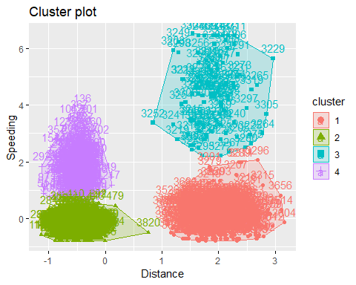

There are 4 very distinct groups clusters that share little to no characteristics with each other. It appearrs that clusters 2 and 4 may share a little.

wine <- read_csv("wineprice.csv")

## Parsed with column specification:  
## cols(  
## Year = col_double(),  
## Price = col_double(),  
## WinterRain = col_double(),  
## AGST = col_double(),  
## HarvestRain = col_double(),  
## Age = col_double(),  
## FrancePop = col_double()  
## )

wine2 = select(wine,Price,WinterRain,AGST,HarvestRain)  
  
wine2_scaled = as.data.frame(scale(wine2))  
  
summary(wine2_scaled)

## Price WinterRain AGST   
## Min. :-1.32596 Min. :-1.73332 Min. :-2.25947   
## 1st Qu.:-0.84329 1st Qu.:-0.52375 1st Qu.:-0.45801   
## Median : 0.08284 Median :-0.03992 Median : 0.03548   
## Mean : 0.00000 Mean : 0.00000 Mean : 0.00000   
## 3rd Qu.: 0.65777 3rd Qu.: 0.69339 3rd Qu.: 0.82524   
## Max. : 2.19343 Max. : 1.69885 Max. : 1.68888   
## HarvestRain   
## Min. :-1.4856   
## 1st Qu.:-0.8003   
## Median :-0.2494   
## Mean : 0.0000   
## 3rd Qu.: 0.5165   
## Max. : 1.9275

set.seed(123)  
fviz_nbclust(wine2_scaled,kmeans, method = "wss")

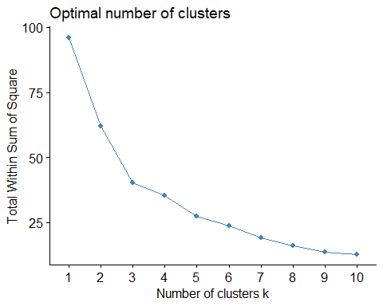

fviz_nbclust(wine2_scaled,kmeans, method = "silhouette")

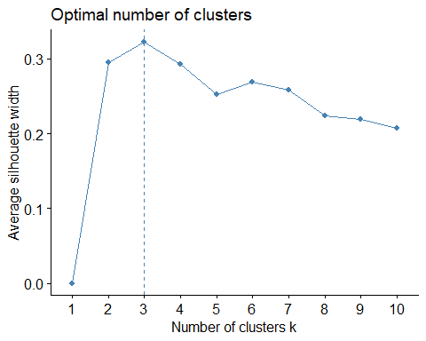

The consensus of the optimal amount of clusters from the two methods is 3.

set.seed(1234)  
  
clusters2 <- kmeans(wine2_scaled,3)  
clusters2

## K-means clustering with 3 clusters of sizes 9, 10, 6  
##   
## Cluster means:  
## Price WinterRain AGST HarvestRain  
## 1 0.3739208 -0.9420566 0.82245903 -0.00155276  
## 2 -0.9571657 0.2511378 -0.78867116 0.66702979  
## 3 1.0343950 0.9945219 0.08076338 -1.10938718  
##   
## Clustering vector:  
## [1] 1 3 1 1 2 1 2 3 3 2 1 2 3 2 2 2 3 1 2 1 2 1 1 2 3  
##   
## Within cluster sum of squares by cluster:  
## [1] 12.947249 19.777763 7.701898  
## (between_SS / total_SS = 57.9 %)  
##   
## Available components:  
##   
## [1] "cluster" "centers" "totss" "withinss"   
## [5] "tot.withinss" "betweenss" "size" "iter"   
## [9] "ifault"

fviz_cluster(clusters2, wine2_scaled)

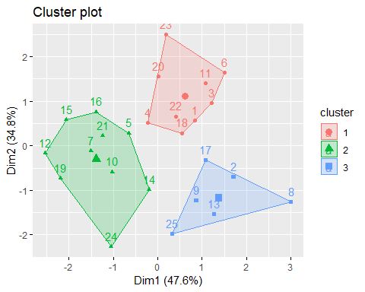

m = c("average","single","complete", "ward")  
  
names(m) = c("average", "single", "complete", "ward")  
  
ac = function(x){  
   
 agnes(wine2_scaled,method = x)$ac  
}  
map_dbl(m,ac)

## average single complete ward   
## 0.5949197 0.3924333 0.7720220 0.8458307

hc=agnes(wine2_scaled, method = "ward")  
pltree(hc, cex=.6,hang =-1, main = "Agglomerative Dendogram")

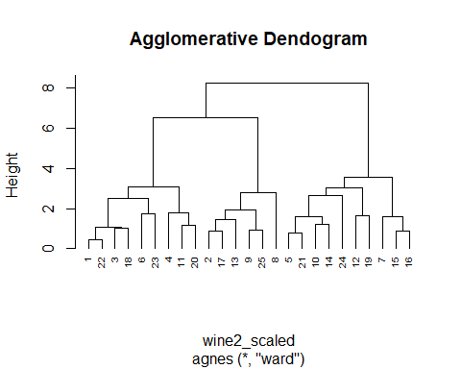

hc2 = diana(wine2_scaled)  
pltree(hc2, cex=.6,hang =-1, main = "Divisive Dendogram")

